

Automating Data Import and Relationship Mapping
Using Import Sets & Dot Walking

PROBLEM STATEMENT:
Your organization wants to regularly import a list of new employees with their details, such as Name, Email, Department, and Manager, from an external system. Once imported, when an Incident is assigned to an employee, the Incident form should automatically show the manager's email of the employee's department.

OBJECTIVE:
- Import employee records from an external CSV file into ServiceNow
- Automatically map relationships between employees, departments, and managers using dot-walking
- Create a staging table and transform map for structured data loading
- Use Mapping Assist for field-level mapping between source and target tables
- Configure the Incident form to display dot-walked fields (Department, Email, Manager)
- Verify imported data by testing via the Incident form

SKILLS:
Using Import Sets & Dot Walking

TASK INITIATION

MILESTONE 1: Import Data from Data Source

ACTIVITY 1: Create Records in the Sheet

Steps:

  - Open a spreadsheet (Excel or Google Sheets)
  - Add the following column headers: name, e-mail id, phone number, department, manager
  - Fill in employee data rows under each column
  - Rename the sheet tab to: employee data
  - Download / Save the file in CSV format

ACTIVITY 2: Load Data into ServiceNow Import Set

Steps:
- Login to ServiceNow Developer instance
- Click Start Building on the homepage
- Go to All → Search: Import Sets → Click Load Data under Import Sets
- Fill the following details:

Fill:
  - Label: import employee
  - File: Upload the CSV file created above

- Click Submit

Result: ImportProcessor runs and data is loaded into the staging table u_import_employee.
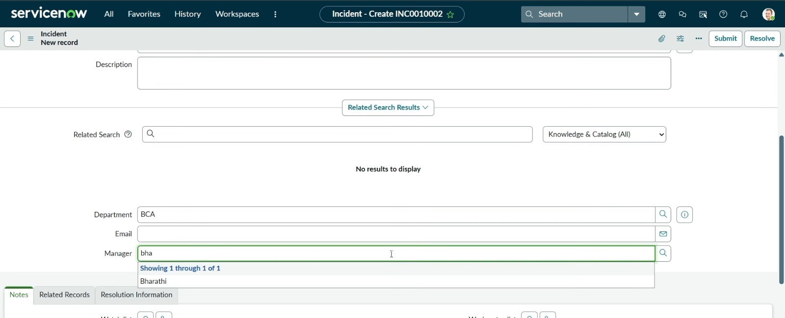

MILESTONE 2: Create Transform Map

ACTIVITY 1: Creating Transform Map

Steps:
- Go to All → Search: Transform Map → Click Create Transform Map
- Fill the following:

Fill:
  - Name: employee transform
  - Source Table: import employee [u_import_employee]
  - Target Table: User [sys_user]

- Click Submit

ACTIVITY 2: Auto Map & Mapping Assist

Steps:
- Scroll down and click employee transform to open it
- Scroll down and click Auto Map Matching Fields
- The auto-matched fields will be shown
- Click Mapping Assist link
- From Source: import employee — select fields: name, e-mail id, phone number, department, manager
- Map them to corresponding Target: User fields
- Click Save

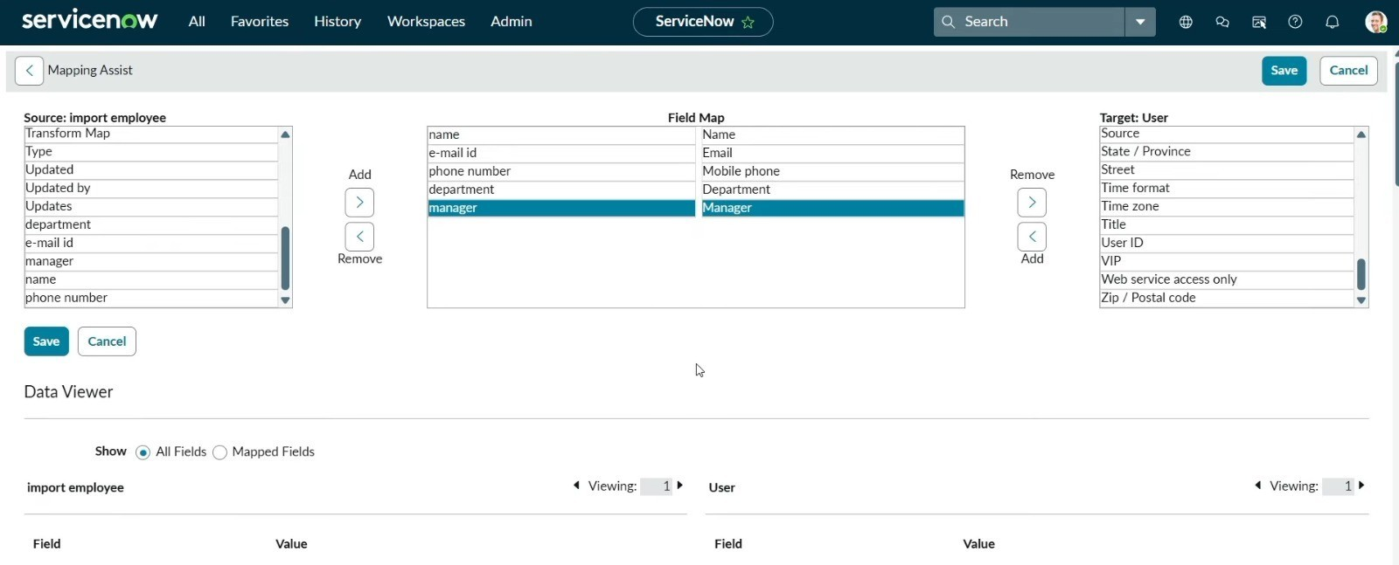

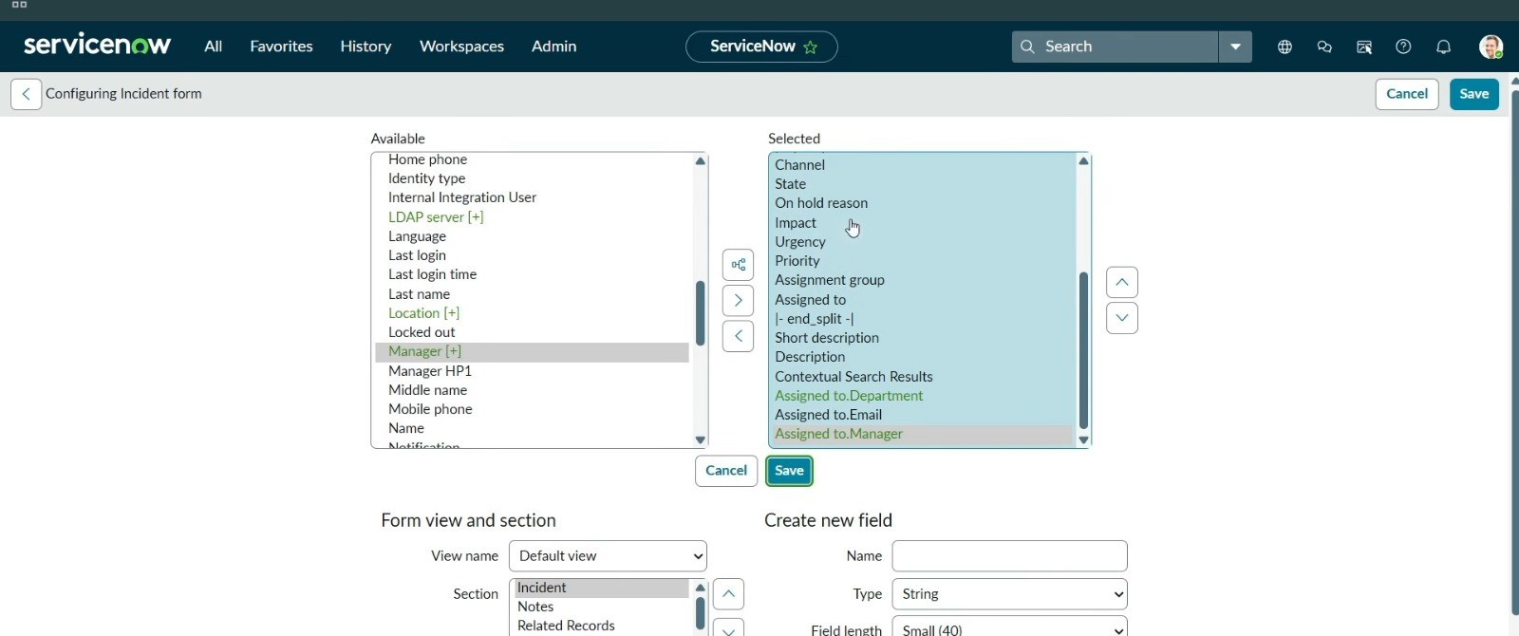

MILESTONE 3: Run Transform

ACTIVITY 1: Execute Transform

Steps:
- Click Transform link inside the Transform Map

- Import set: ISET0010001 - u_import_employee is selected
- Ensure employee transform - sys_user is in Selected maps
- Click Transform button
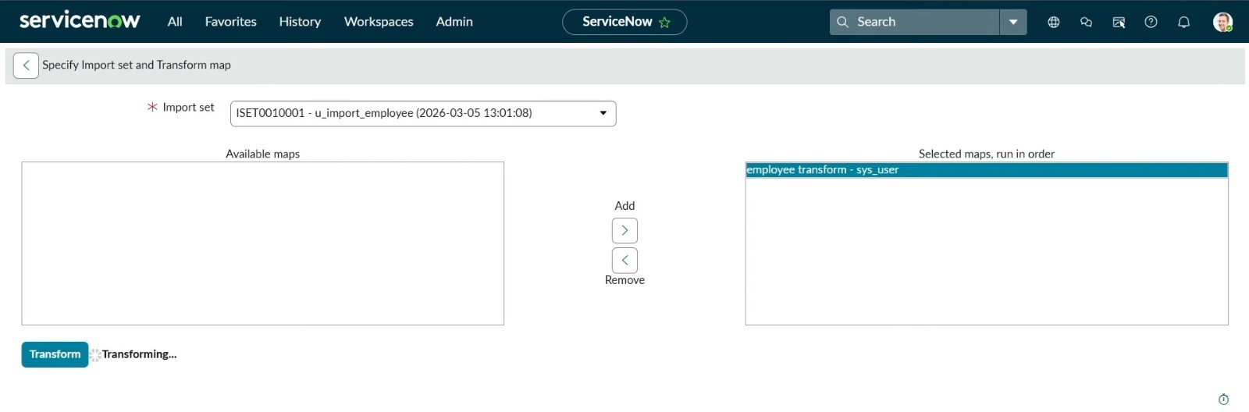

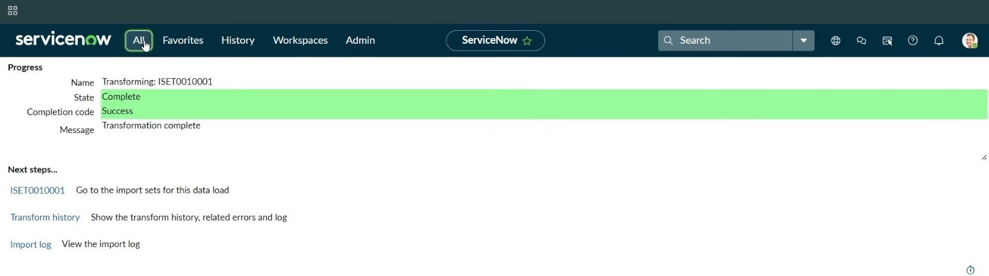

Result:
  - State: Complete
  - Completion code: Success
  - Message: Transformation complete

MILESTONE 4: Dot Walking – Configure Incident Form

Dot Walking allows traversal of related table fields and displays them directly on a form. In this task, we configure the Incident form to show the assigned employee's Department, Email, and Manager using dot-walked fields from the User table.

ACTIVITY 1: Configure Incident Form Layout

Steps:
- Go to All → Search: Incident → Click Create New under Incident
- On the Incident form, click Configure → Form Layout
- In the Available column, find Assigned to — expand it
- Select: Assigned to.Department, Assigned to.Email, Assigned to.Manager
- Move selected fields to the Selected column
- Click Save
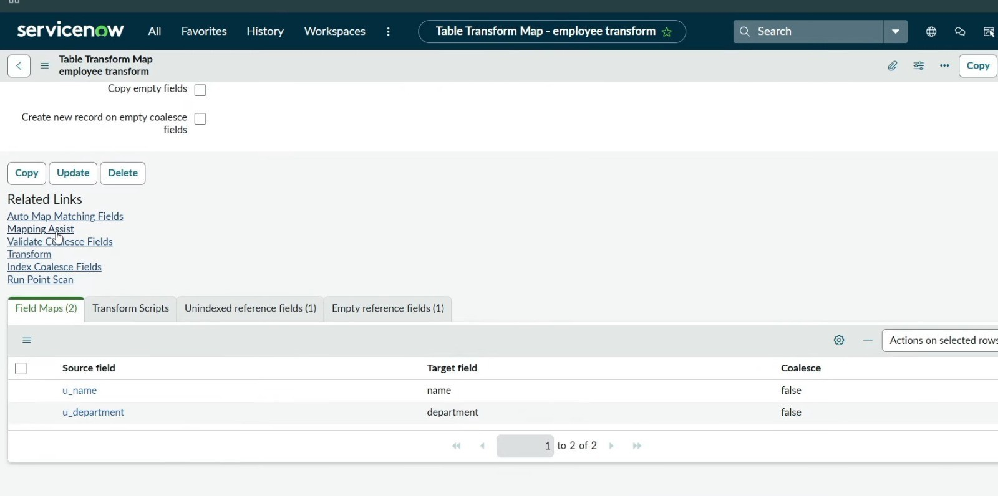

MILESTONE 5: Testing

ACTIVITY 1: Verify Imported Data in User Table

Steps:
- Go to All → Search: User → Select User under User Administration
- Verify all imported employee records appear correctly
- Add User ID for each record and click Update

ACTIVITY 2: Test Dot Walking on Incident Form

Test Case:
- Go to All → Incident → Create New
- In the Department field, click search icon — departments popup appears
- Select a department (e.g., BCA)
- In the Manager field, type partial name (e.g., bha)
- System auto-suggests matching manager records
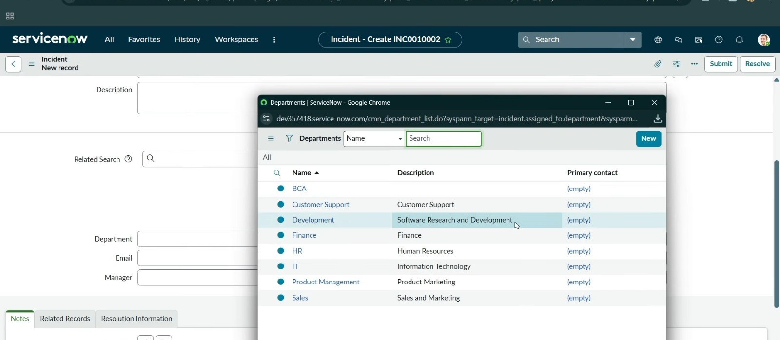

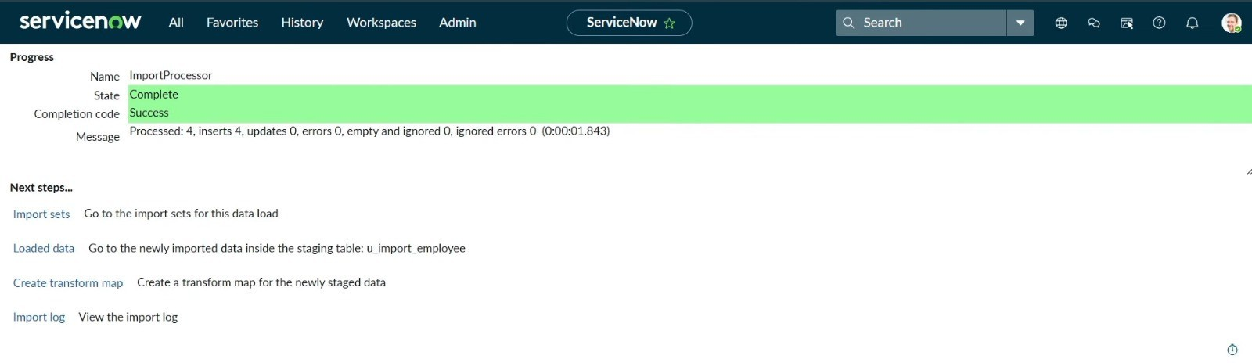

Expected Result:
  - System displays Department, Email and Manager fields on Incident form
  - Manager field auto-suggests using dot walking

Actual Result:
  - Department field correctly shows all available departments
  - Manager field successfully dot-walks to show: Bharathi
  - Dot Walking working correctly ✓

RESULT
  - Employee data successfully imported from CSV into ServiceNow using Import Sets
  - Transform Map (employee transform) mapped all fields correctly to sys_user table
  - Processed: 4 inserts, 0 updates, 0 errors — clean import
  - Dot Walking configured on Incident form — Department, Email, Manager displayed
  - Relationship mapping between employees, departments and managers working correctly
  - No manual data entry required — full automation achieved

CONCLUSION
This project successfully demonstrates how to automate data import and relationship mapping in ServiceNow using Import Sets and Dot Walking. By loading employee data from a CSV file into a staging table (u_import_employee) and using a Transform Map to move it to the sys_user table, manual data entry was eliminated entirely.

Dot Walking was configured on the Incident form to automatically display related fields — Department, Email, and Manager — by traversing the relationship between the Incident and User tables. This improves data quality, reduces manual effort, and ensures accurate relationship mapping across ServiceNow tables.

This project demonstrates best practices in:
  - Data Import Automation using Import Sets
  - Field Mapping using Transform Maps and Mapping Assist
  - Relationship Mapping using Dot Walking
  - ServiceNow Form Configuration
  - ServiceNow Administration and Development

